Name : Antonius Marcelino

Class : 5_IKI

Student ID : 23151010466

Repository : https://github.com/CaneToad-Marceline/web-sem5

W3C HTML Tutorial Report

1. Introduction and editors (knowing the Base of HTML and the code editors)

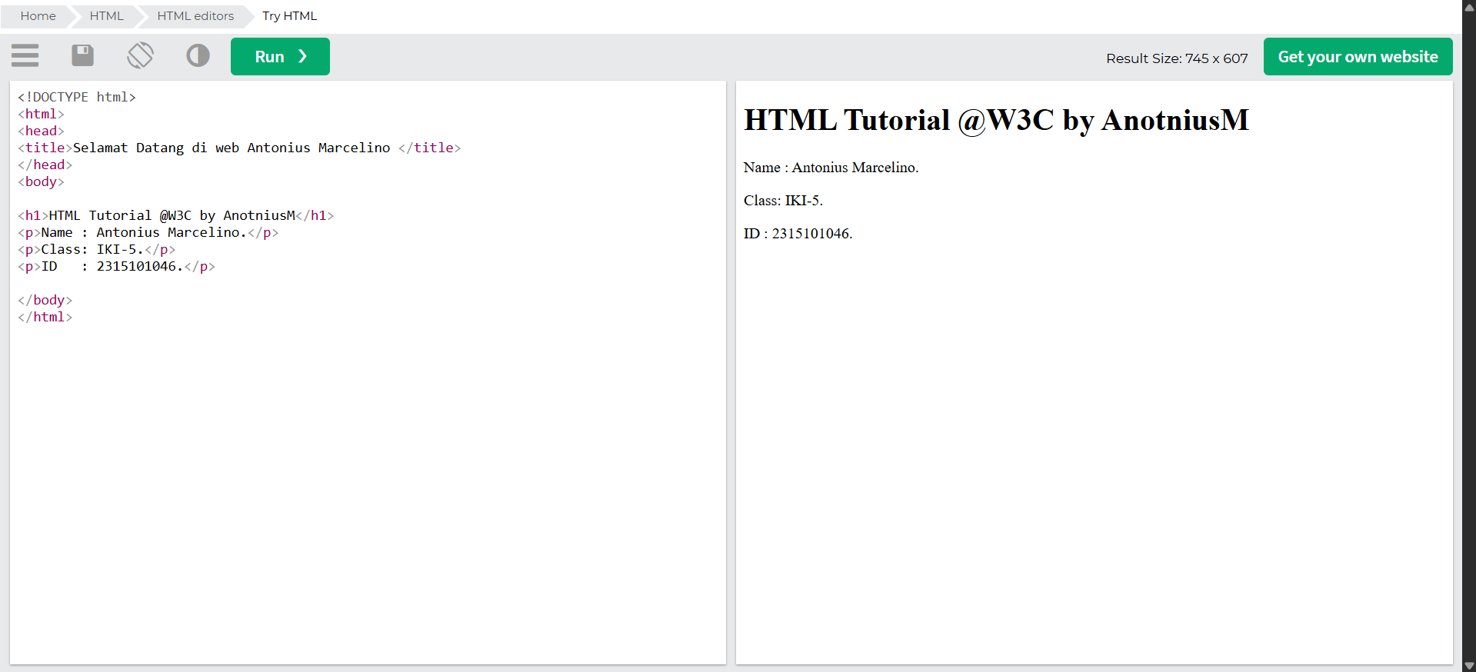

1. HTML Basic (Knowing more about The Heading, Paragraph, Link ref and also image)

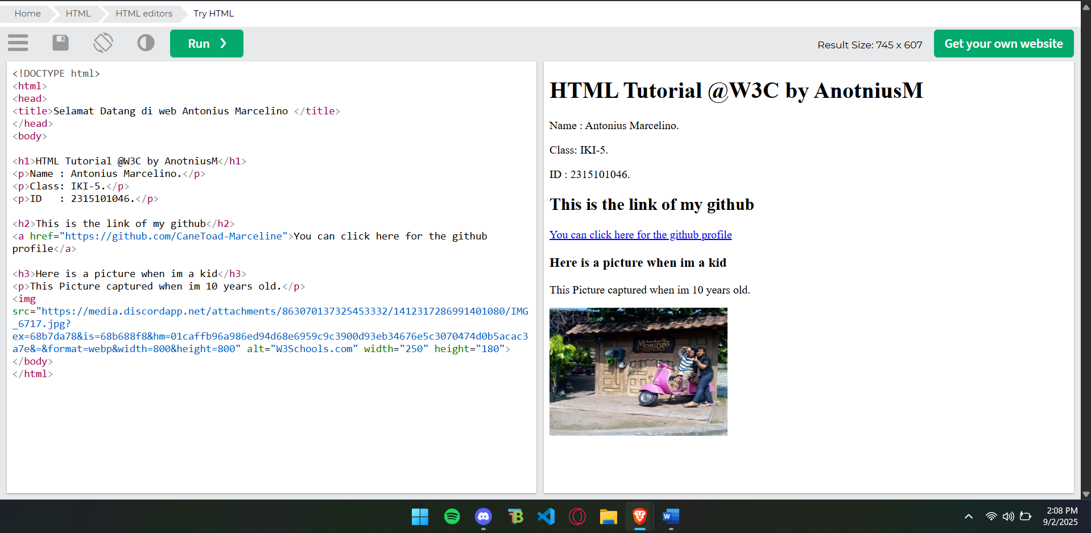

1. HTML Elements ( using the Nested Element and break line)

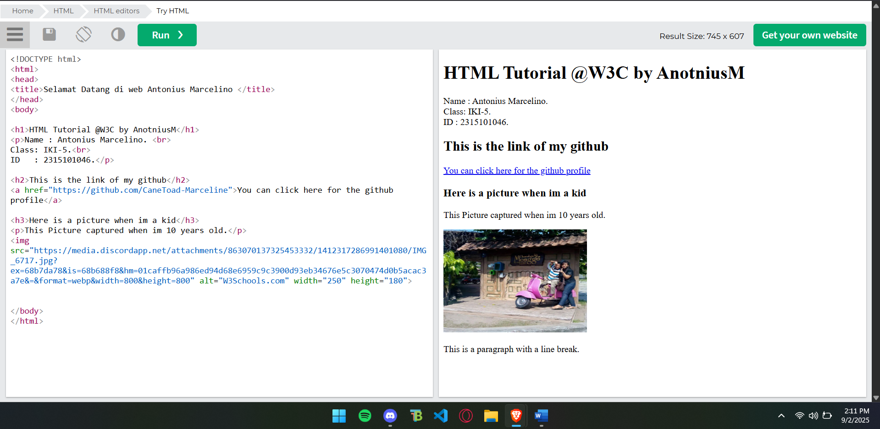

1. HTML Attributes (using the colour attribute to change colour of text)

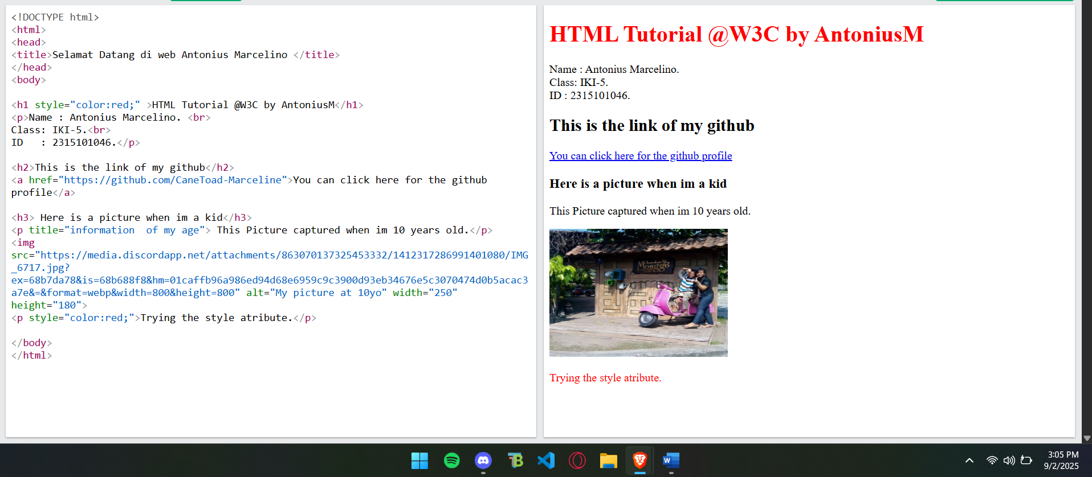

1. HTML Headings, Paragraph and Styles ( Messing around with the background and text style)

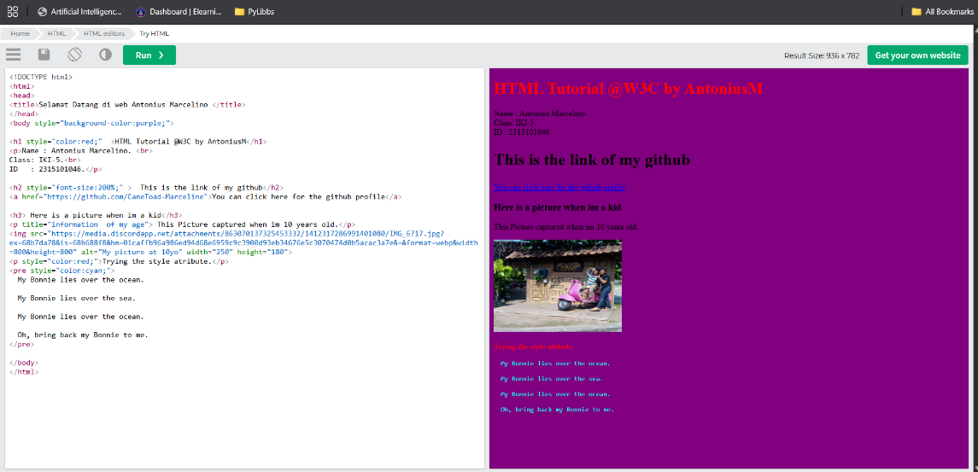

1. HTML Quotation (<blockquote> for Quotations)

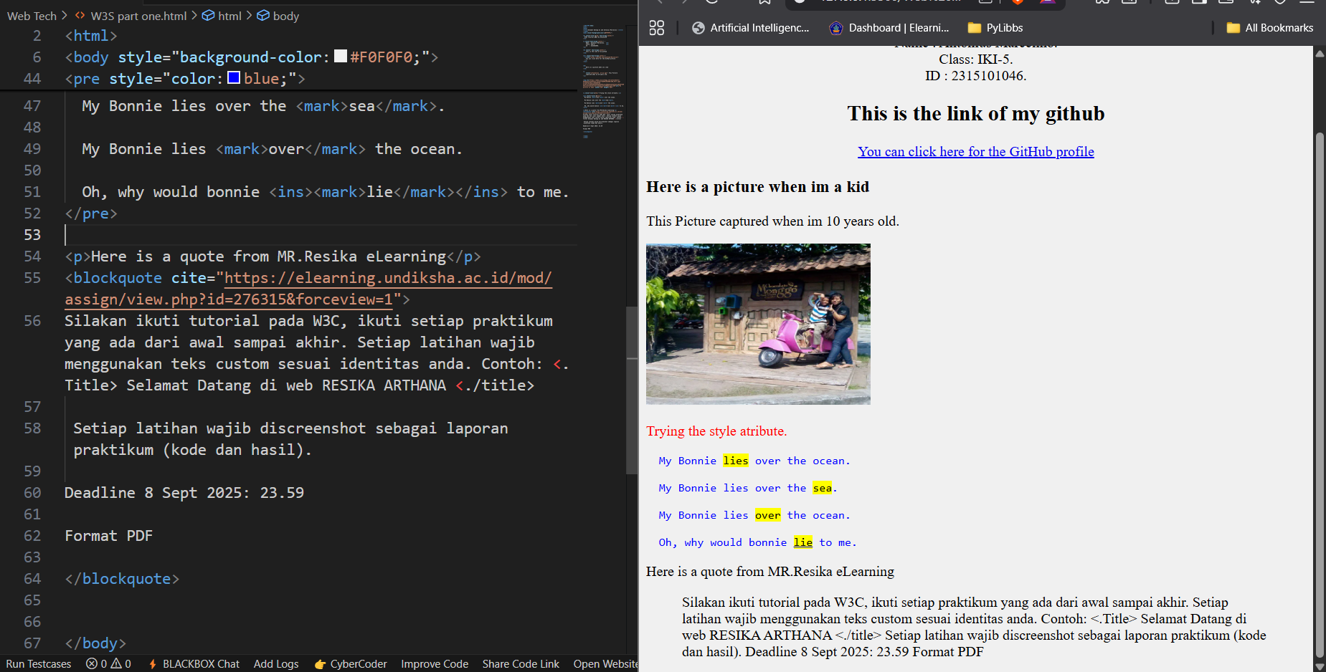

1. HTML Comment <!—using this syntax for comment -->

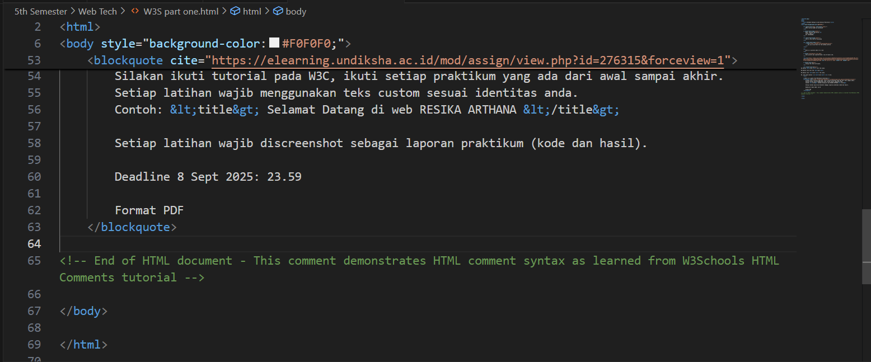

1. HTML Colour To Make a border around the image

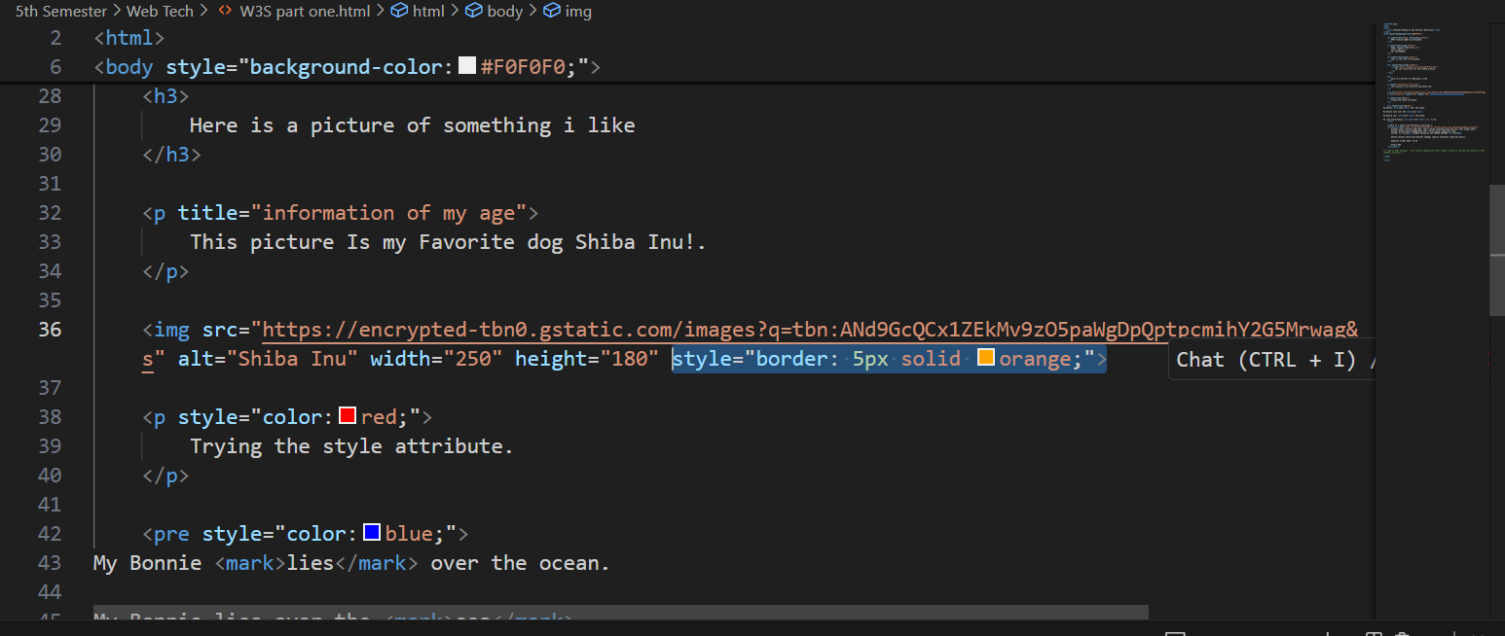

1. HTML Styles – CSS So I convert the code to use the internal CSS which uses class for the styling and can be recalled when used again.

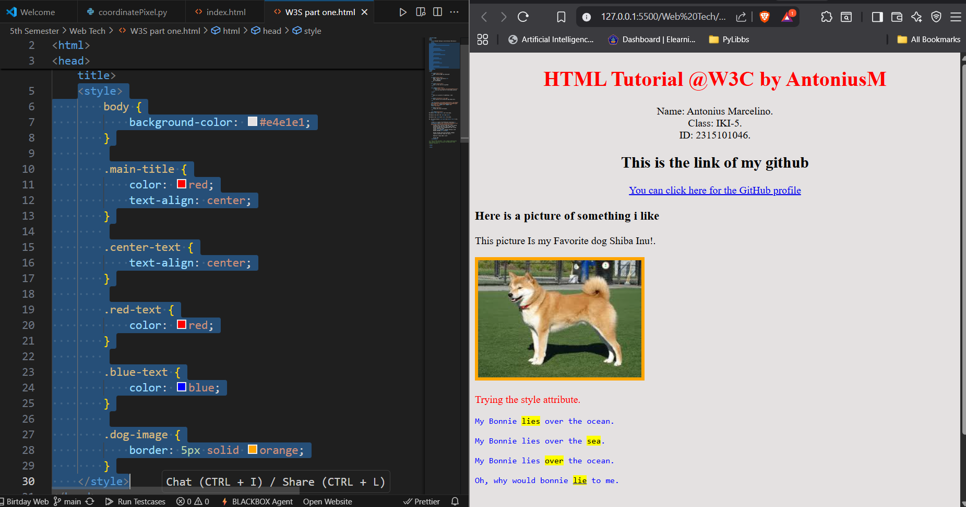

1. HTML Links – Different Colours so I added the CSS to show the link state.

* An unvisited link is underlined and blue
* A visited link is underlined and grey
* An active link is underlined and red

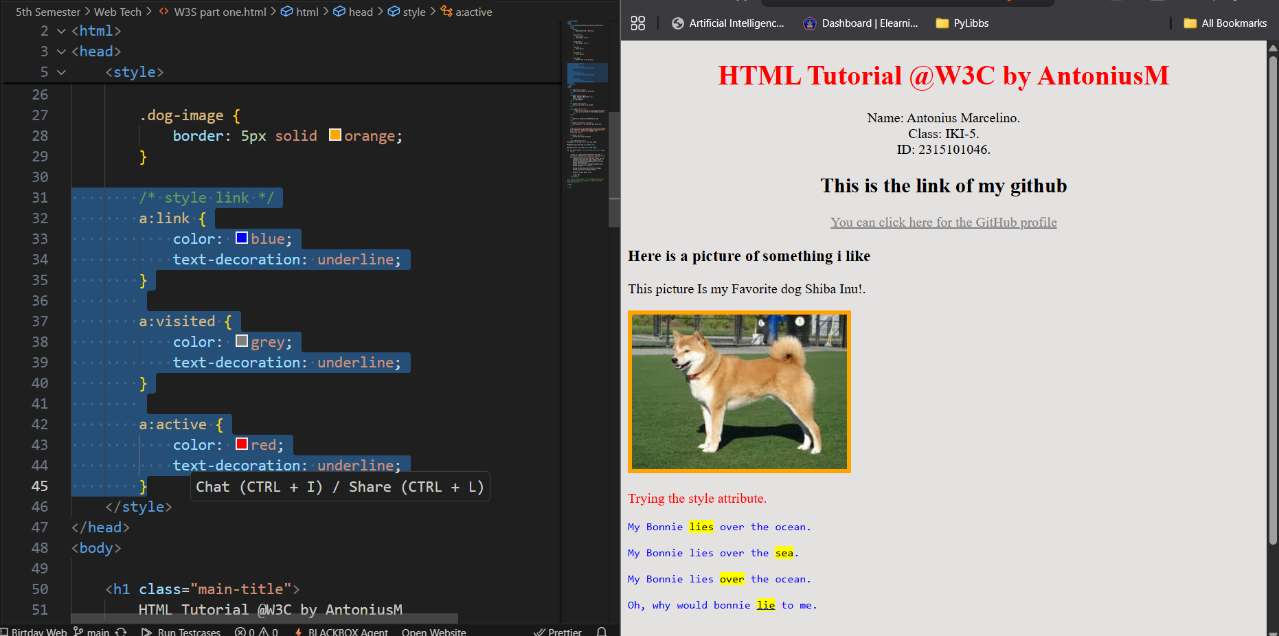

1. HTML Images – Images Map. An image map is an image with clickable areas. So simply a overlay over the object that can be clicked and referencing into a link.

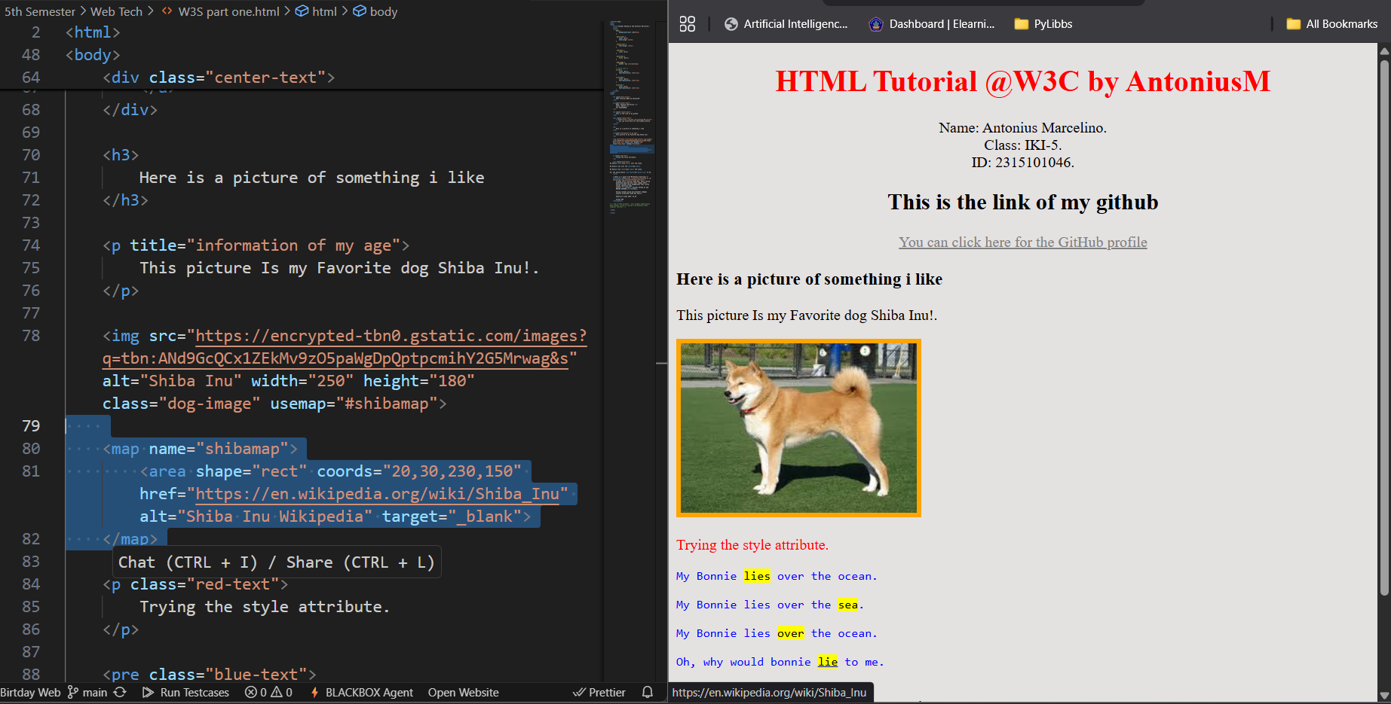

1. Change the icon of website (Favicon)

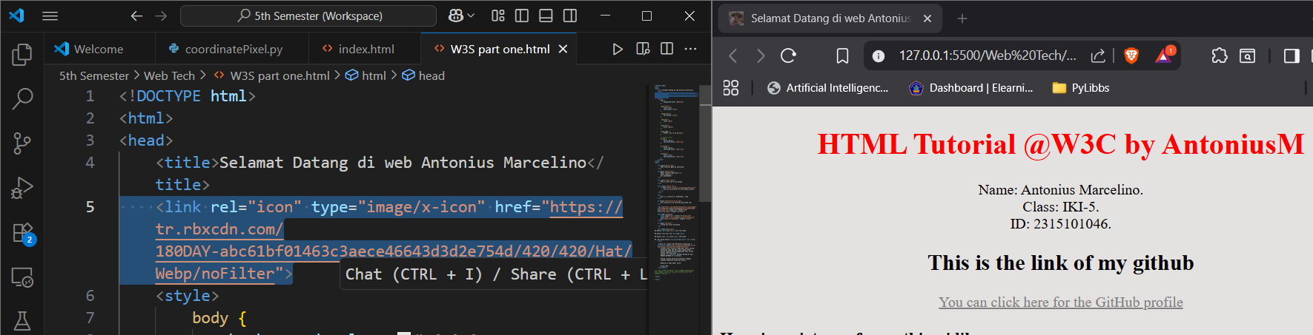

1. Title. Use the title that require in the assignment

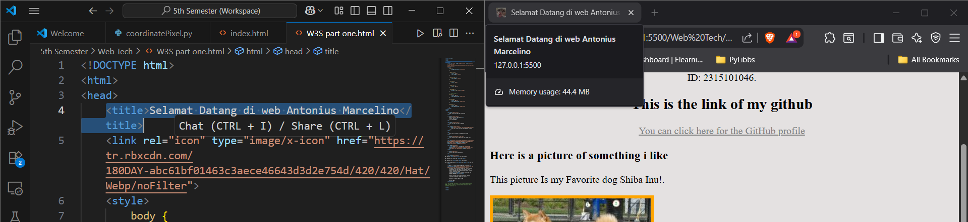

1. HTML Tables – Adding a Table also Internal CSS for the border and background styling

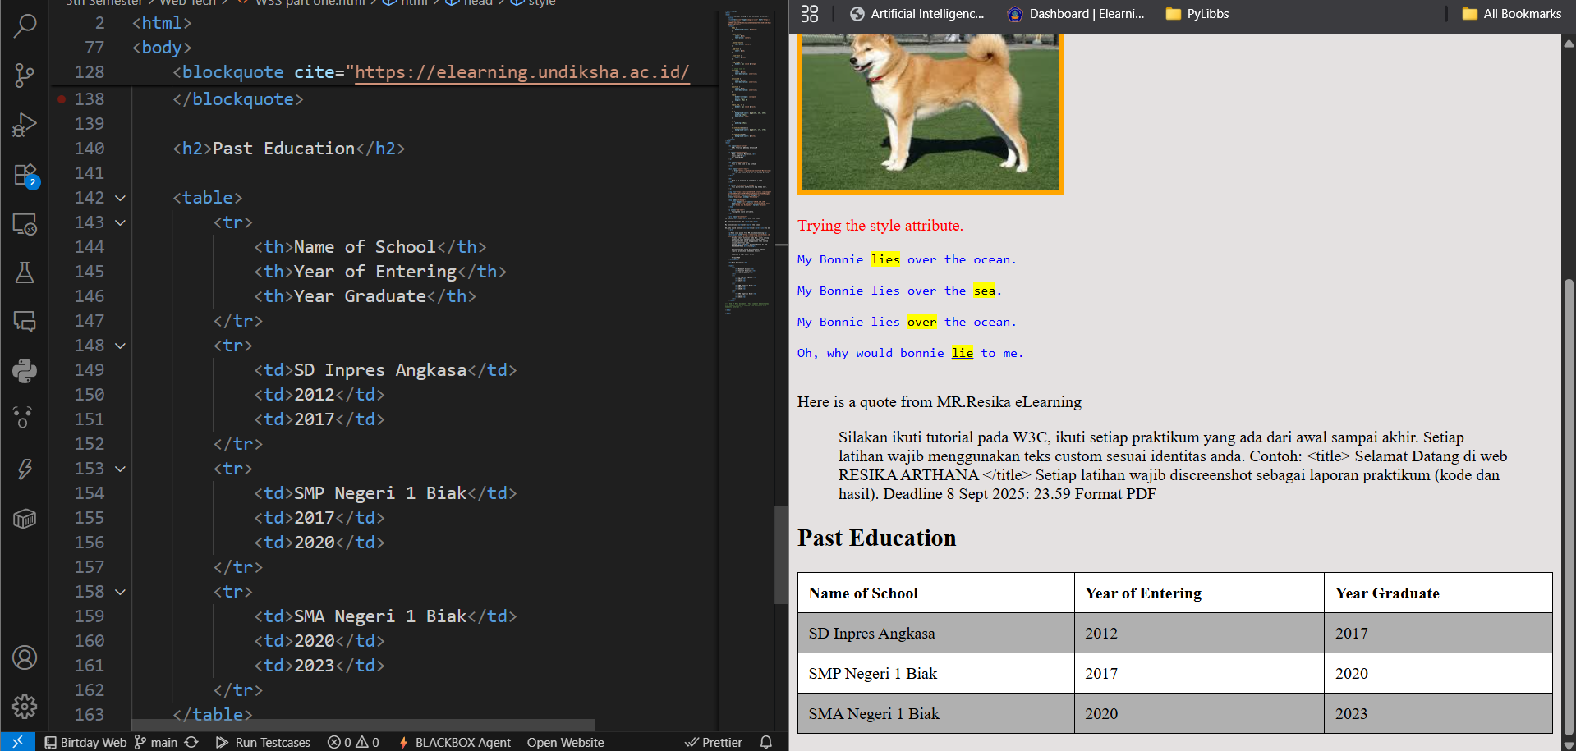

1. HTML List Tags, as it highlighted I make a ordered and un-ordered list of food

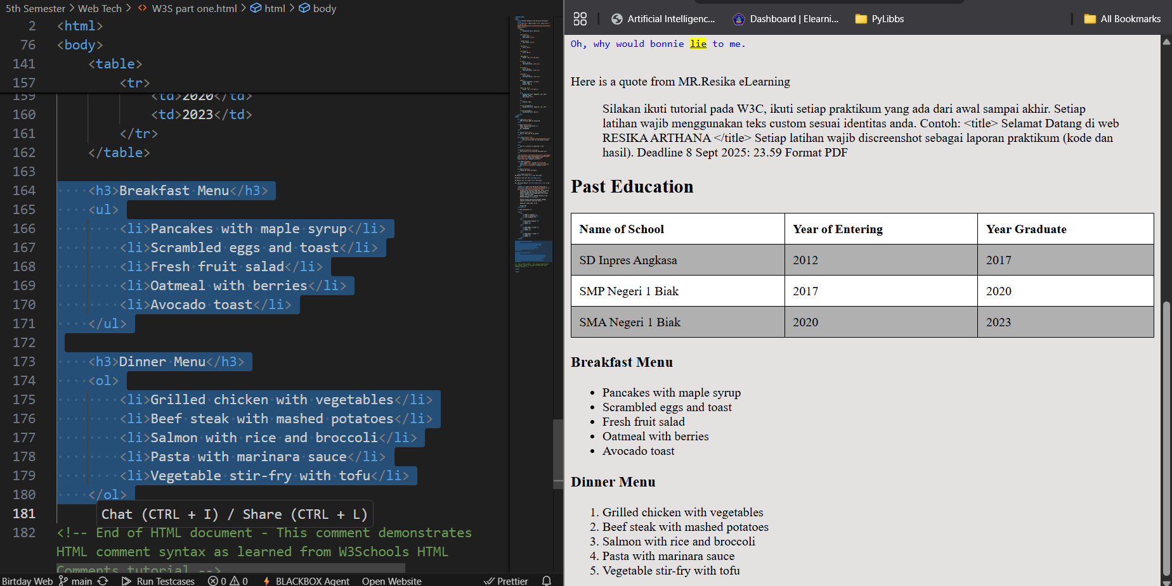

1. HTML Block and Inline, Span element. Use span element to highlight the words.

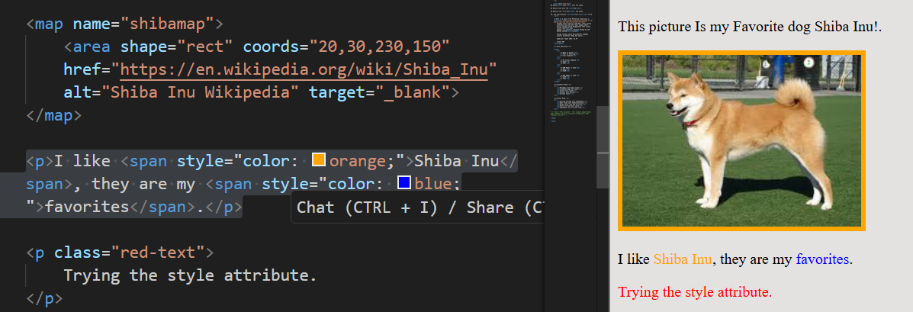

1. HTML Div & Class– Aligning Div element side by side. Creating the CSS and put the list into class

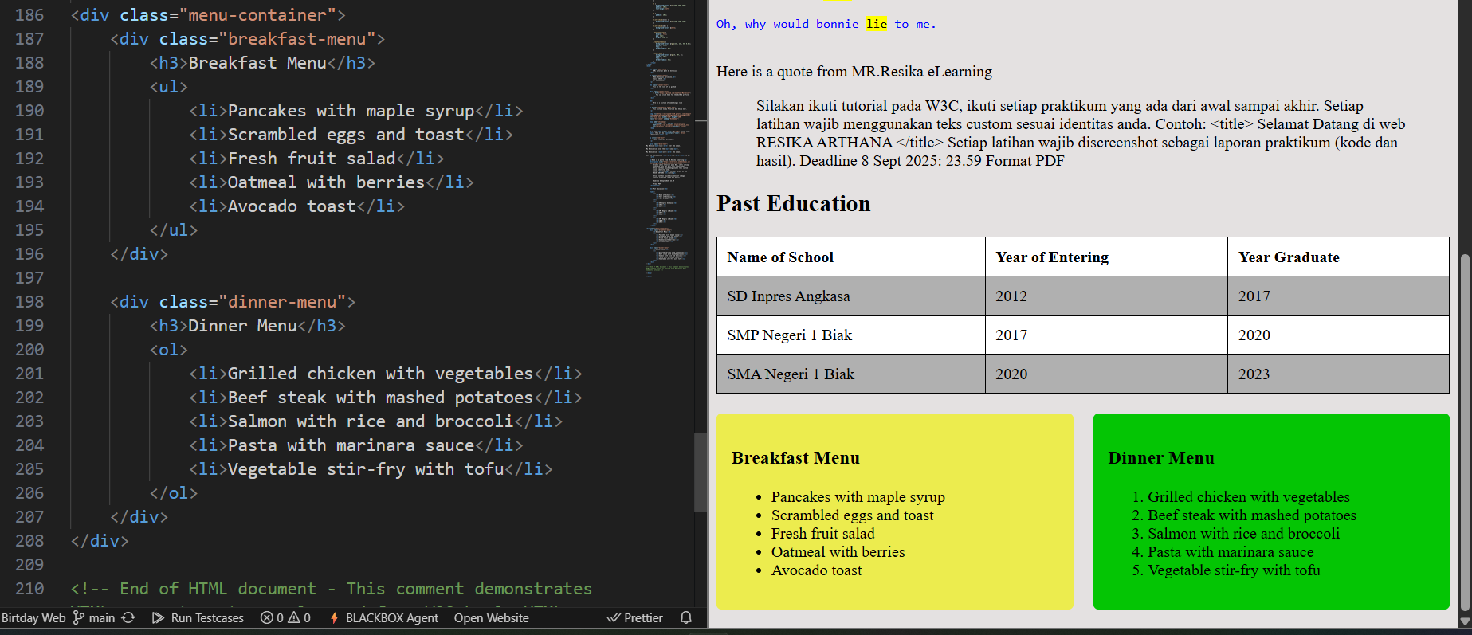

1. HTML id attribute. Changing the Main Title into a unique ID from a class

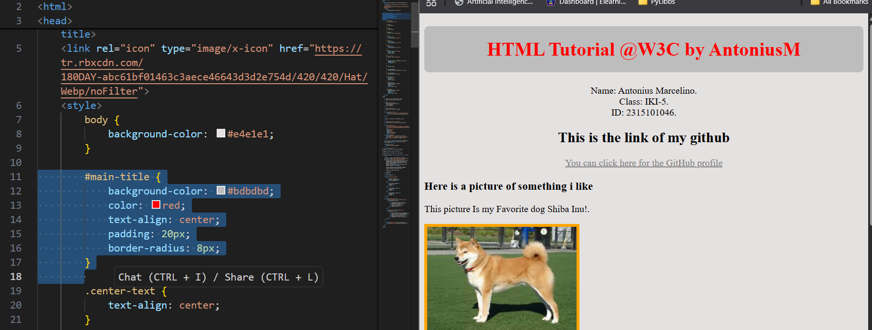

1. HTML IFrame. Used to make a frame that can directly referencing to a web in a smaller screen or page.

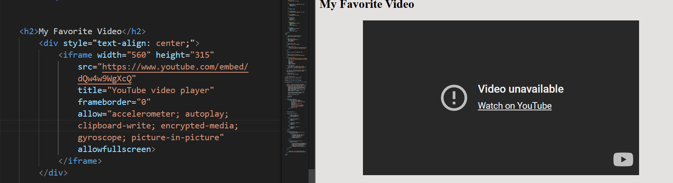

1. HTML JavaScript. I made a script that able to change the images attribute.

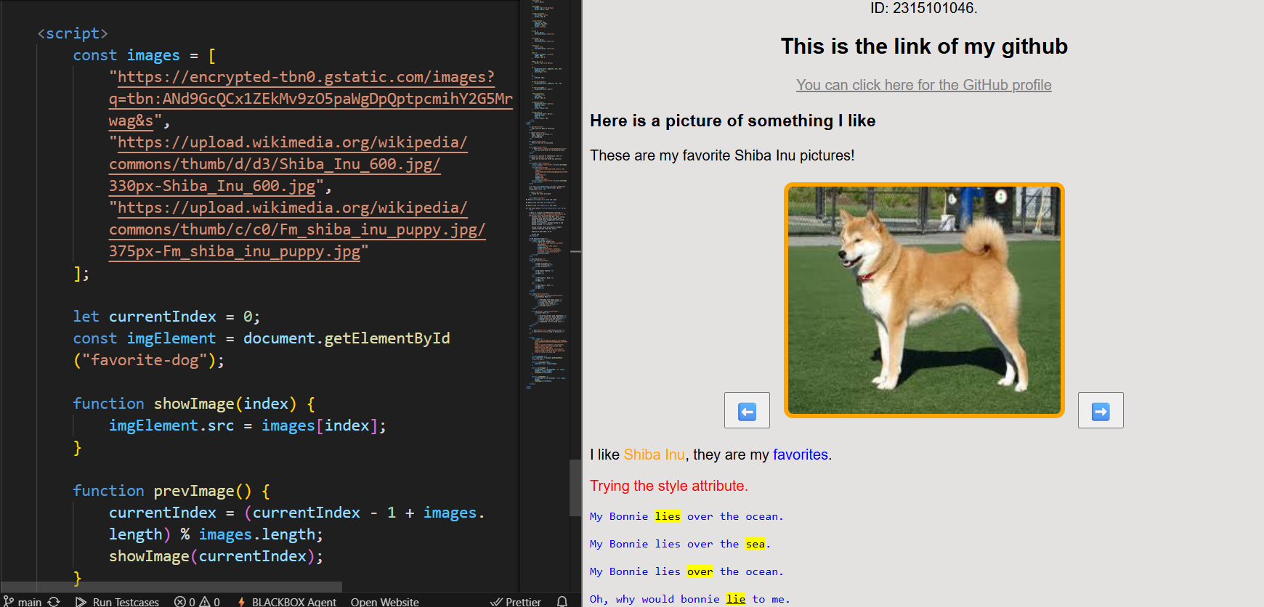

1. HTML Pathing.

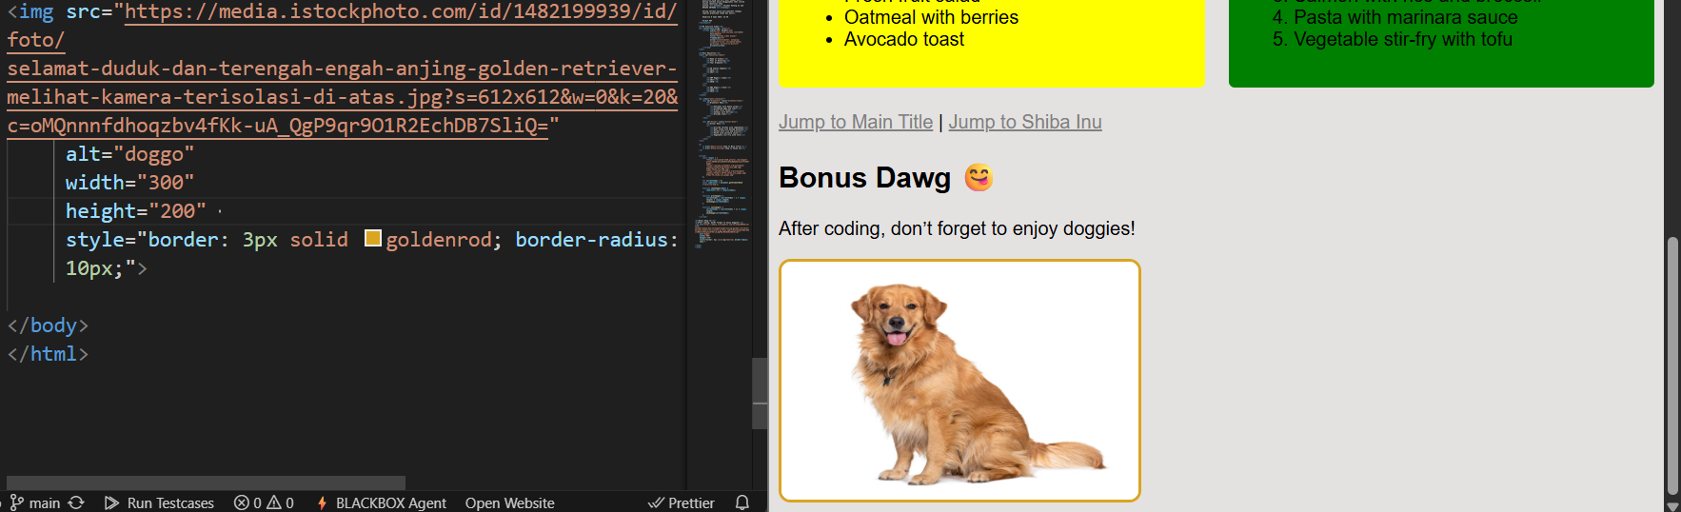

1. Setting The Viewport. Using viewport so the user's visible area of a web page. It varies with the device.

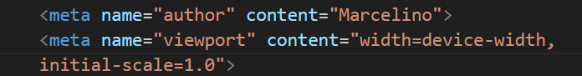

1. HTML LAYOUT – I used the Grid Layout for this time (header, nav bar, main content, side cotent and footer)

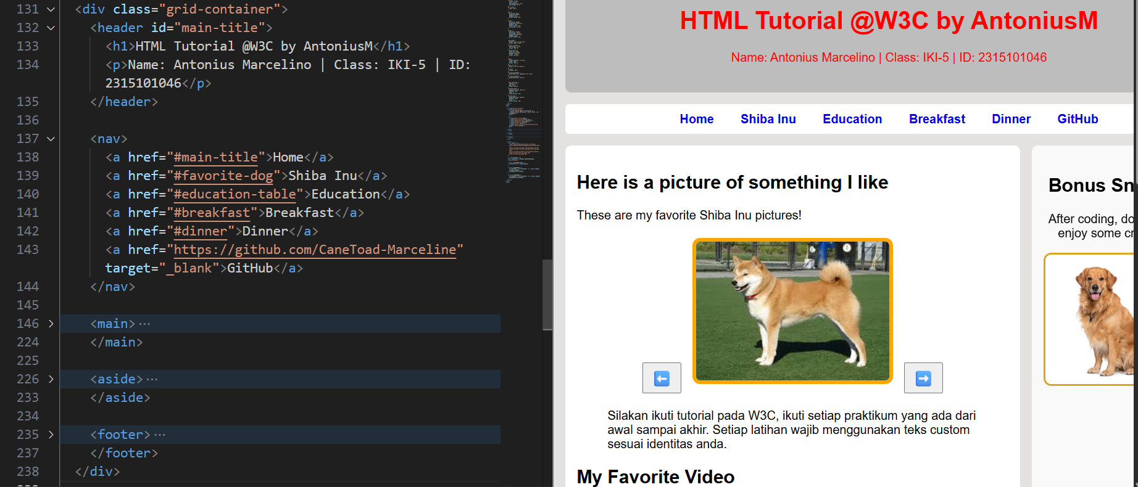

1. HTML responsive web design using media queries. We add a CSS styling to make the grid stacked underneath when its compacted

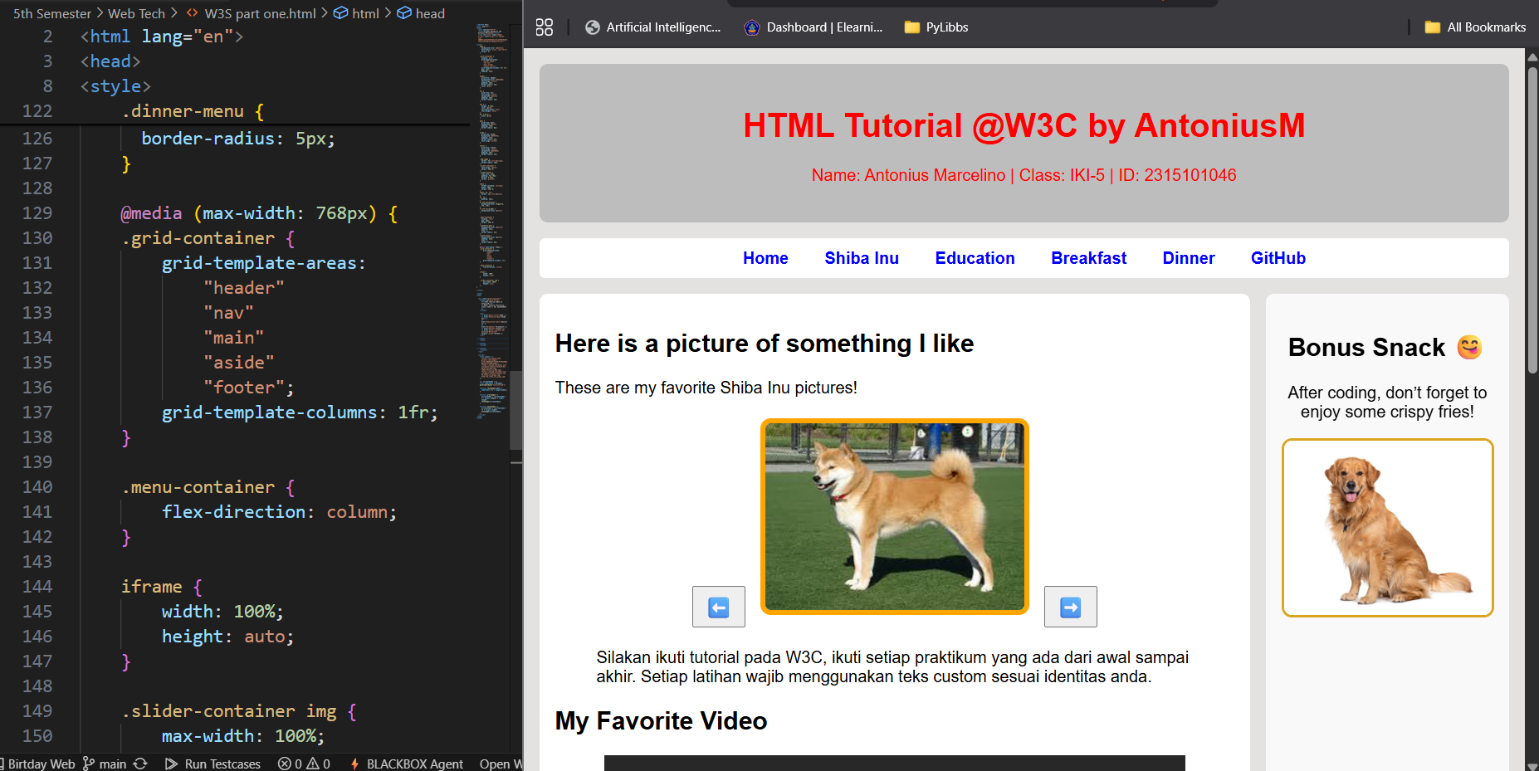

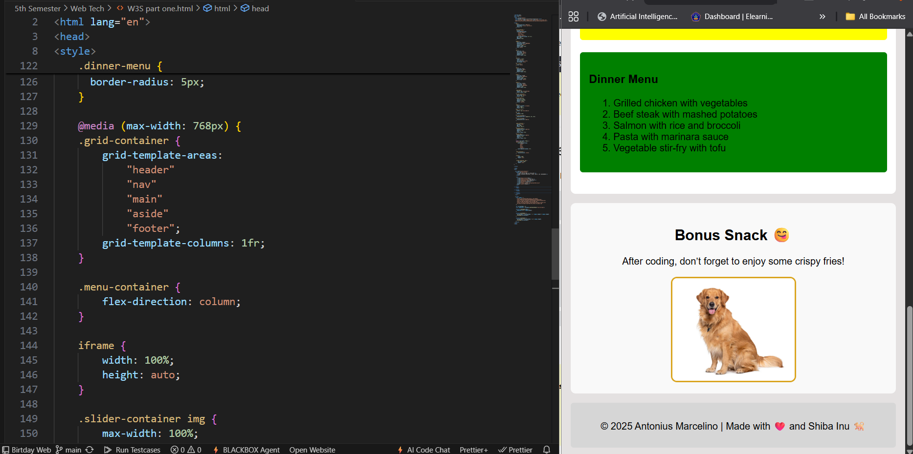

In the 2nd image, the side page get automaticly put down.

1. HTML Computer Code Element displaying code snippets using <code> within a <pre> like style

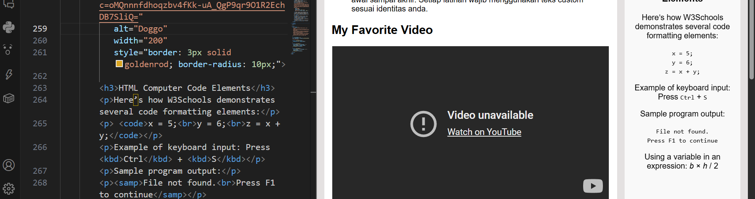

1. HTML Semantic Elements. Creating a section using the article and CSS to separate it.

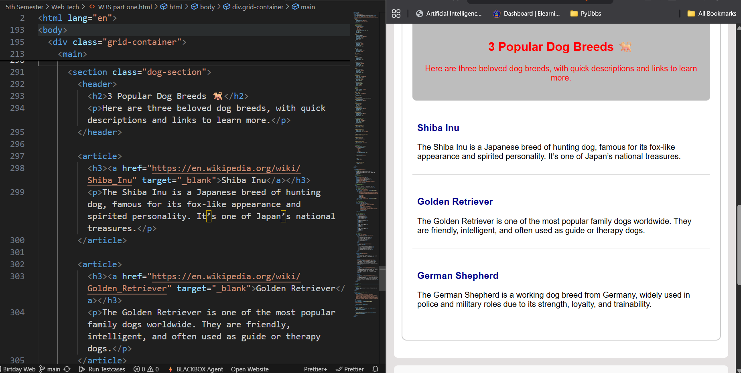

1. HTML Entities and Symbol. Using the © symbol by &copy;

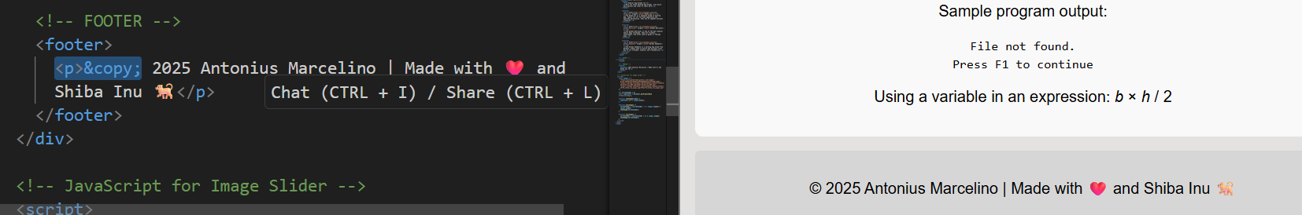

1. HTML Emoij’s using HEX

